**Lesson 6 Demo 2**

**Setting Up Custom SMTP to Send Email Notification**

**Objective:** Configure Jenkins to setup custom SMTP to send build notifications.

**Tools required:** Jenkins

**Pre-requisites:** You need to have a Jenkins up and running.

Steps to be followed:

1. Log in to Jenkins CI tool and configure SMTP configurations in Jenkins

**Step 1: Log in to Jenkins CI Tool and create new Jenkins Job**

1. Login to Jenkins CI tool with admin user and navigate to Manage Jenkins to access Email configuration section.

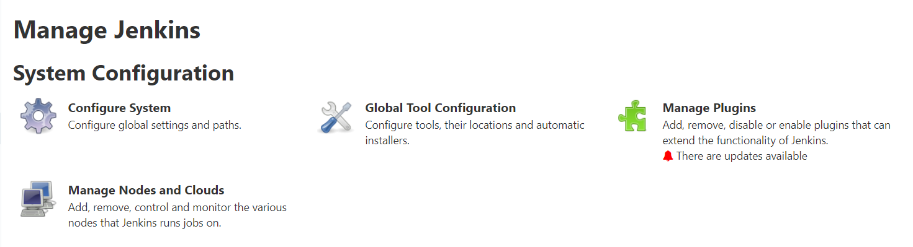

1. Then click on Configure System and navigate to the bottom of page to **Extended E-mail Notification** section.
2. Provide SMTP details as below to configure email alerts configuration:

***Gmail SMTP server name: smtp.gmail.com***

***Gmail SMTP username: your Gmail address***

***Gmail SMTP password: your password***

***Gmail SMTP port: 465***

